# Department of Computing

**NAME:** ALI HASSAAN MUGHAL

**REGISTRATION:** 173627

# MATH 333: Numerical Analysis

# Class: BSCS-6AB

# Lab 6: Newton Raphson method for system of non linear equation & Curve Fitting

# Date: March 08, 2019

# Time: 10:00-12:50hrs & 14:00-16:50hrs

# Instructor: Atifa Kanwal

# Lab Engineer: Azaz Farooq

**Lab Task 1**

Implement Newton Raphson method for system of non-linear equation. Take function, initial guess, tolerance and other required parameter as input from user. Find its roots.

**Code:**

syms x y;

F = @(x,y) [4*x^2 - 20*x - (1/4)*y^2 + 8; (1/2)*x*(y^2) + 2*x - 5*y + 8];

Jacob = jacobian([F],[x,y]);

X1 = [0;0]

FX1 = double(F(X1(1),X1(2)))

while max(FX1) > 0.001

J1 = subs(Jacob,{x,y} , {X1(1),X1(2)});

J1det = det(J1);

J1adj = zeros(2,2);

J1adj(1,1) = J1(2,2);

J1adj(1,2) = -J1(1,2);

J1adj(2,1) = -J1(2,1);

J1adj(2,2) = J1(1,1);

Jinv = (1/J1det).*J1adj;

XN = double(X1 - Jinv*FX1);

X1 = XN

FX1 = double(F(X1(1),X1(2)))

end

**Output:**

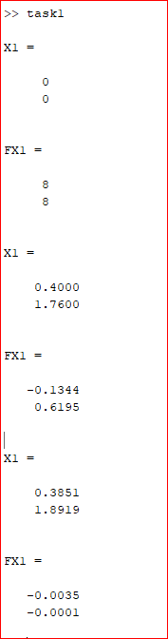

**Lab Task 2**

Calculate and plot a best fit line for this data set.

t=[0:8]; y=[40.12 66.78 80.17 86.71 80.77 66.78 44.41 10.51 -32.60];

Find:

1. What is the slope and intercept?

**Slope: -9.19 Intercept: 86.04**

1. What is the value of y when t=4.5 and t=8.5

**At 4.5 = 44.7016 and 8.5 = 7.9589**

**Code:**

syms x y;

x = (0:1:8)';

y = ([40.12 66.78 80.17 86.71 80.77 66.78 44.41 10.51 -32.60])';

pc = polyfit(x,y,1); %Linear Fit

plot(x,y,'ro');

hold on;

plot(x,polyval(pc,x),'b-');

txt = sprintf('Best fit line y=%.2fx + %.2f', pc(1), pc(2));

legend('Data points', txt);

polyval(pc,4.5)

polyval(pc,8.5)

**Output:**

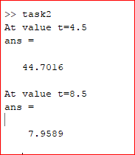

**GRAPH**

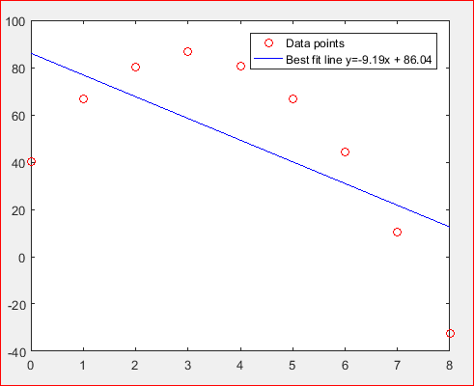

**Deliverables**

Submit single word file with matlab code and screen shot of Output.